Global Encoding
While making an operational coding scheme for the Cognitive process dimension, it was realized there are multiple factors that are helpful in determining the cognitive process occurring in a classroom.
- Intent of teacher
  - It was realized that figuring out the intent of the teacher is pretty helpful in deciding which cognitive processes are taking place in the classroom. It was suggested that the intent of the teacher can be addressed by looking at Global encoding.
- Type of information
  - It was suggested that figuring out what type of information is being taught is also helpful in deciding which cognitive processes are taking place in the classroom. It was suggested that the type of information can be addressed by looking at the Knowledge dimension.
- Time of response
  - It was suggested that in some scenarios, looking at the response time also helps in determining cognitive processes occurring in the classroom especially in scenarios where we have to decide whether an answer is given by “remembering” or by using some other cognitive processes.
- Visual cues
  - It was suggested that looking at the demeanour of students and teachers is quite helpful in certain cases in figuring out the cognitive process dimension, too. Hence, it was suggested that one always look at the video before encoding any transcribed line for any variable.
Note: As mentioned in the operational coding of cognitive processes dimensions, the above factors are there to help in scenarios that are not straightforward to encode. Ideally, the encoding for the cognitive processes dimension should be done on the basis of current actions done by the student, and the standard or subject should not matter when deciding which cognitive processes are taking place in the student's brain. However, since it is not possible for us to know for sure which cognitive dimension is taking place in students' brains, we have to rely on indirect cues mentioned above in case of ambiguities.
Global encoding plays an important role in figuring out the overview of the intention of the teacher and, in turn, the goals a teacher trying to achieve in a particular segment of the classroom. It was suggested that global encoding can be of three types
- Preassesment
  - In this segment, the teacher is trying to access the prior knowledge of students before starting a topic. Generally, the teacher summarises or discusses what has been discussed in previous class in this section. Ideally, it should happen before starting each new topic, but sometimes teachers break the pattern and start discussing “preassessment” in the middle of the other two types of global encoding by generally asking students what has been discussed in previous classes about the topic they are learning. Generally, factual knowledge occurs in this section, but any other knowledge dimension can also occur in this section.

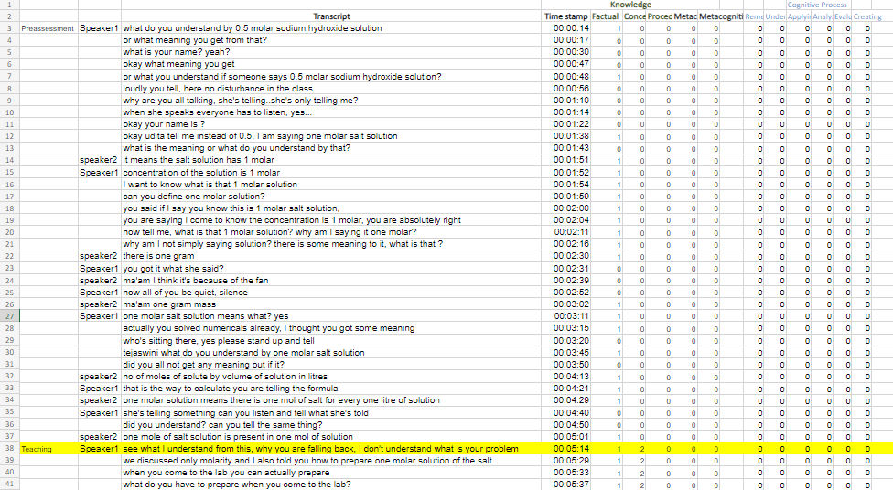
- Teaching
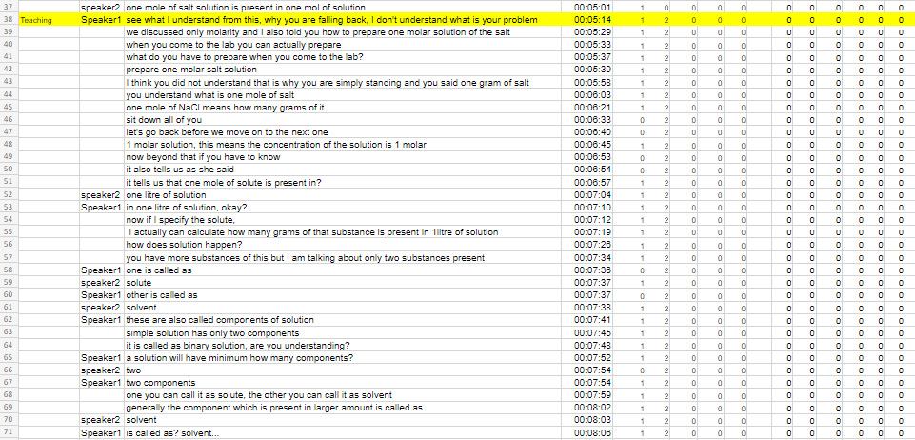
  - In this segment, teachers try to discuss the topic at hand. Asking questions in the middle of teaching involving “remembering” will not always create instances of “preassessment”; rather, these scenarios are counted as part of teaching itself. Only scenarios where the teacher starts discussing what has been discussed in the previous class at length in the middle of teaching will justify the need to break the chunk of “teaching”; otherwise, we will keep the chunking of teaching even in cases where the teacher tries to remind student a single formula or some small thing from previous classes. The reasoning behind this is that we are concerned with the overall intention of the teacher while discussing a section rather than a small intervention by the teacher, which looks like a preassessment or assessment. Generally, conceptual knowledge is discussed in this section, but another knowledge dimension can occur, too.
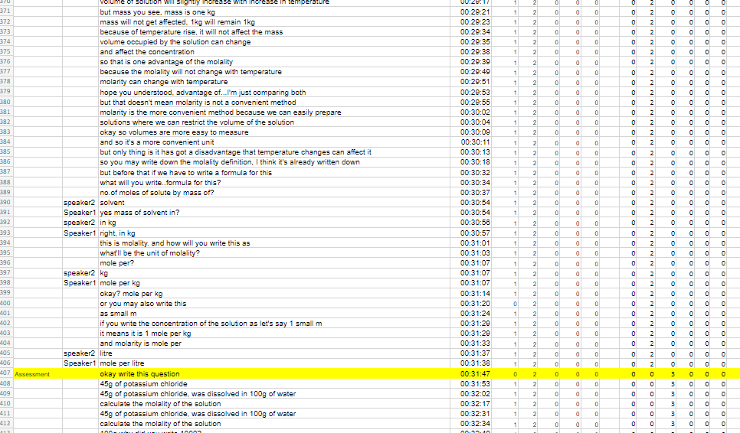
- Assessment
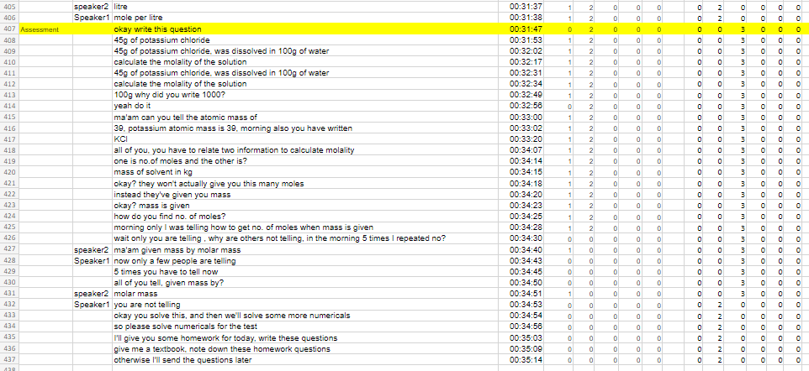
  - In this segment, the teacher generally tries to access what he or she has just taught or taught in the previous class by asking questions.

